

FIN3210 Fintech Theory and Practice  **PROJECT 1 ROBO-ADVISOR**

**Group 10**

120090651 马可轩

120090489 李卓宸

120020128 刘鑫宇

120090717 罗单丹

120020312 周阅月

120090900 田海川

120090856 余松霖

120090452 薛颖

120090814 陈芝霖

120090626 王子潇

**1.1 Client Risk Preference and Investment Goal Assessment**

**1.1.1 Investor Questionnaire:** First and foremost, Vanguard employs an investor questionnaire as a robust tool to assess clients' risk tolerance and investment goals. The comprehensive questionnaire, consisting of 11 questions, can be categorized into 4 key sections: Investment Horizon, Experience and Comfort with Investments, Financial Stability, and Reaction to Market Volatility.

* **Investment Horizon:** This section assesses the duration over which investors plan to spend money withdrawn from their investments and their commitment to long-term investment strategies. The section contains 3 questions.
* **Experience and Comfort with Investments:** Investors are categorized based on their experience levels and comfort with various financial instruments, providing insights into their familiarity with and confidence in different investment options. The section contains 1 question.
* **Financial Stability:** Examines the stability of current and future income sources.The stability of current and future income sources, such as salary, social security, and pensions, is examined to gauge the overall financial stability of the investor. The section contains merely one question.
* **Reaction to Market Volatility:** Investor responses to historical market scenarios, including bond and stock losses, are analyzed to understand their risk tolerance and behavioral tendencies during periods of market turbulence. The question contains 7 questions.

**1.1.2 Additional Information:** Collects detailed user information post-account creation, tailored to specific investment areas like retirement, education savings, and emergency funds.

**1.2 Portfolio Construction Techniques**

Vanguard’s proprietary portfolio construction models are the quantitative foundation of Vanguard’s portfolio construction framework. Two models/optimizers used in tandem are the VCMM, our simulation engine for asset return and risk forecasts, and the VAAM, our portfolio optimization engine.

**1.2.1 VCMM**

VCMM generates Asset return distributions, not just asset return point forecasts. Portfolio construction uses the full range of VCMM statistical return distributions, including return volatility and correlations, in addition to the long-term average (or expected) returns.

* **Key Features:** The Vanguard Capital Markets Model (VCMM) employs a probabilistic framework, focusing on medium- to long-term economic and market valuation forecasting, as short-term forecasting is less reliable. It accounts for the sensitivity of medium-term return projections to initial conditions, like price-earnings ratios and interest rates. The model also relies on forward-looking assumptions for economic drivers such as inflation, productivity growth, and central bank policies, based on inputs from Vanguard’s Global Economics team. Additionally, it allows for a nonnormal distribution of returns, implying a greater likelihood of extreme market events than a normal distribution would suggest. This comprehensive approach aids in creating more accurate and adaptable investment strategies.
* **Time-varying expected returns and portfolio implications:** The two sets of VCMM forecasts generally used in their portfolios are long-term forecasts (30 years or more), and medium-term forecasts (typically 10 years). However, there is a key issue thatMedium-term asset return forecasts (i.e., the full distribution of returns) can change with the market environment, such as periods of extreme equity market valuations, large and persistent shifts in interest rates, or high-inflation regimes, to name a few market drivers.An illustrative plot is described below:

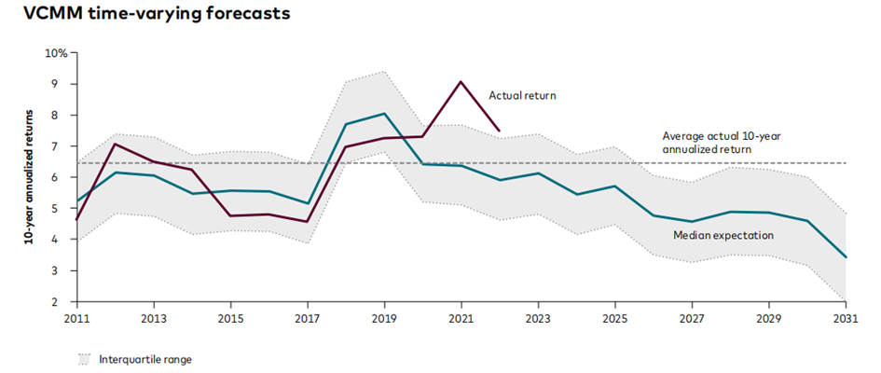

**1.2.2 VAAM**

VAAM uses a utility-driven representation of investor outcomes to maximize investors’ chances of achieving their financial goals, conditional on their risk tolerance.

A range of investments is then selected, including various asset classes, factors, and active products. The VCMM provides expected asset return distributions, including volatility and correlations, as inputs for these investments. Finally, the VAAM uses these inputs to balance the potential rewards against the risks of each investment, guided by the investor's risk tolerance through utility-driven optimization.

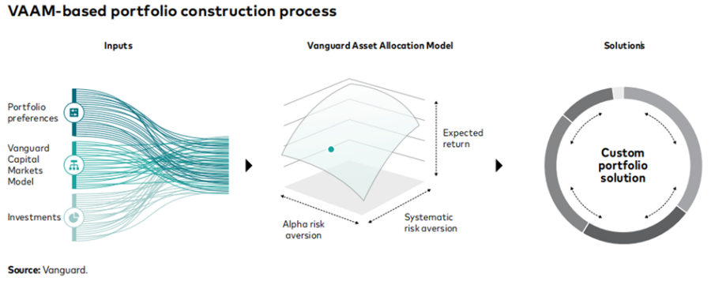

**1.3 Asset Class Investment Universe Selection**

**1.3.1 Use of Vanguard’s ETFs:** Vanguard’s Digital Advisor service primarily utilizes its own proprietary ETFs to create personalized retirement plans and portfolios for investors. This approach is centered on a selection of key ETFs (exchange-traded funds) that are well-diversified, though the range may be more limited compared to some other robo-advisors that offer a wider variety of asset classes.

**1.3.2 Client Risk Assessment and Portfolio Customization:** Clients complete an online financial questionnaire, including details about income, tax status, and linking outside accounts. Vanguard’s risk-tolerance tool then assesses the client’s attitude toward risk and establishes retirement goals. The portfolio is customized according to these inputs and aligned with the client’s retirement goals, with ongoing management provided.

**1.3.3 Investment Portfolio Options:** Clients can choose from three investment portfolio options: (1)All-Index, (2)Active/Index, and (3)ESG (Environmental, Social, and Governance). Each option comprises Vanguard funds and ETFs, and each made up of Vanguard funds and ETFs, and adjusted based on personalized inputs.

**1.3.4 Passively-Managed Investment Approach:** Vanguard Digital invests in four Vanguard funds for the passively-managed option, including U.S. and international stock and bond funds. The percentage invested in each fund is derived from the client’s initial goals and risk questionnaire.

**1.3.5 Personalized Investment Strategies:** With Vanguard’s Personal Advisors service, clients work with a financial advisor to craft a portfolio that satiates their needs. There are three strategies to choose from: Core (passively managed index ETFs), Active and Passive (actively managed and passive index fund ETFs), and ESG (ESG stock and bond ETFs only).

**1.4. Estimation of Variances and Correlations Between Asset Classes**

As far as we know, Vanguard's robo-advisor service for estimating variance and correlations between function classes are not public disclosed. We cannot find specific technical details about how to do esitmate, but we can infer some strategies from its white paper.

As our discussion of the robo-advisor MPT above, Vanguard use the Vanguard Capital Markets Model (VCMM), which works as a simulation engine to generate not only the assets' returns, but their distributions. The generated distributions can be directly used to calculate the variance and correlations between function classes. As its white paper stated, the generated distributions are relaible because it mainly focuses on medium term and long term forcasts instead of the volatile short term forcasts. The model is robust also because it allows non-normal distributions of returns, which can handle extreme market events that may not be expected by simple normal distributions. The variances and correlations produced by VCMM are them feeded to VAAM to optimize the portfolio.

In addition to the VCMM, Vanguards may also use some simple statistical methods to estiamte variance. For example, robo-advisor may use assets' historical data and analyze how different assets have behaved under different environments. Also, Monte-Carlo simulations may be used to estimate the variance and correlations by modelling the assets' future performance. But these methods are just our conjecture and are not explicitly indicated in its official document.

1. **Feature of Vanguard robo-advisor**

**2.1 Specific features offered by Vanguard’s robo-advisor**The **Vanguard Digital Advisor** is a robo-advisor providing cost-effective investment management for your risk preferences and financial goals. The **Personal Advisor Services**, a hybrid model, for investors use the platform or seek guidance from human advisors.

**2.1.1 Vanguard Digital Advisor Features**

**Digital Fees and Investment Minimum:** The annual net advisory fee is lower than many competitors. **Digital Advisor Sign-up:** Investors create a Vanguard account, answer questions, helping the algorithm accurately predict retirement probabilities. **Digital Investment Strategy:** Vanguard Digital invests in passively-managed Vanguard funds. **Rebalancing:** Rebalancing, done quarterly, aims to mitigate portfolio volatility.

**2.1.2 Vanguard Personal Advisor Services Features**

**Fees and Investment Minimum** An option for a combined index and active management approach. The fee structure is flexible.**Rebalancing and tax-loss harvesting** Tax loss harvesting allows investors to determine if optimal. **Financial Advisors** Financial advisors, offer guidance on financial and life planning questions. **2.2 Unique and Competitive Features of Vanguard**

**Low Digital and Personal Advisor Fees:** Vanguard's Personal Advisor boasts a 0.35% management fee, one of the industry's lowest. The 0.40% AUM for a mix of index and active management is competitive. The annual net advisory fee for an all-digital portfolio is 0.20%, undercutting many competitors. **Automated portfolio management with human advisors.**

The entire process is driven by a human financial advisor, collaborating with investors to create customized investment plans.

**3. Capital Requirement and Fee Structure**

Vanguard Digital Advisor, Vanguard's automated investing service, has a specific fee structure and capital requirement. Here are the key details:

**3.1 Capital Requirement**

To enroll in Vanguard Digital Advisor, you need a minimum of $3,000 in each Vanguard Brokerage Account. For eligible 401(k) plan participants, the minimum account requirement is $5.

**3.2 Fee Structure**

**Annual Net Advisory Fee:** Approximately 0.15% for typical investment portfolios, such as all-index or ESG portfolios. For clients with an active/index portfolio, the net advisory fee ranges from 0.11% to 0.20%. The actual net fee may vary based on the specific holdings within your account. New clients are offered a waiver of the net advisory fee for the first 90 days of enrollment.

**Account Fees:** Vanguard Digital Advisor lists its annual, transfer, and closing account fees as "None," indicating that there are no additional charges for these specific account activities.

This fee structure and capital requirement aim to provide a balance between accessibility and cost efficiency of consulting services for a wider range of investors. At the same time, not charging additional account fees further reduces the total cost for investors, making this service more attractive.

**4. Challenges and Opportunities**

**4.1 Opportunities**

**Low Management Fee**: The management fee of Vanguard is no more than 0.2% which is the lowest among the main-stream robo-advisor (Wealthfront about 0.25% and Betterment varies from 0.15% to 0.35%). A hybrid mode advisor supported by famous public fund manager Vanguard with the lowest fee will be an attractive investment opportunity.

**Domestic and Foreign Funds Revive**: After the Covid-19, the market has revived and full of incentives. The domestic fund is searching for more return in a safer way. Besides, the foreign fund is also revived and there is large demand for investment opportunities.

**Upward Fintech Trend**: Fintech is becoming a hot topic in investment market. The fintech industry has aroused investors' interests and the robot-advising market rapidly expands in the past 10 years, which gives Vanguard more opportunities to occupy the market.

**4.2 Challenges**

**Challenge 1:** **Relatively Insufficient Customer Experience**. We already know that Vanguard has two robo-advisor services, one is Digital Advisor service with account minimum $3000 and the other is Personal Advisor service with account minimum $50000. $3,000 is already a relatively high threshold compared with competitors, but there is still no human service, which makes many customers complain about it and the customer experience is not good. Even if the investment of more than $50,000 has human service, there is still a problem of low-cost performance. Moreover, most individual investors have little tendency to choose Vanguard Personal Advisor service with the limit of $50,000.

**Challenge 2: Relatively High Requirement for Access**. The minimum enrollment amount of Vanguard is $3000. The relatively high requirement for access is a barrier for Vanguard to expand in the market.

**Challenge 3:** **Restrictions for Non-U.S. Investors**. Vanguard's robo-advisor business may have restrictions for non-U.S. investors. Vanguard has cooperated with Ant Financial, but the cooperation is not smooth, and the progress in China is not as good as other foreign institutions. Recently, Vanguard even withdrew from China and closed its China office. These are obviously not conducive to directly attracting Chinese investors and expanding overseas markets.

**Challenge 4: Relatively Narrow Business Scope of Robo-Advisor and Relative Slow Innovation**. As a traditional financial institution, Vanguard’s robo-advisor business is still relatively new compared with its long-developed and mature traditional business. And Vanguard is relatively slow to adopt new innovations. That means Vanguard is a pure "robo-advisor" product, unlike its rivals, such as Wealthfront, etc., which introduce consumer loans, financial planning tools, and even tax savings on investment losses. Vanguard has only the most basic robo-advisor functions: risk questionnaires, asset allocation, and automatic positioning.

**5. Actions to Cope with Competitions and Challenges**

**Strategy 1: Regular customer feedback and improvement and introduce more human service options.** To solve challenge 1,collect customer feedback regularly, understand customer needs and grievances, and improve accordingly. By conducting surveys and building customer feedback channels, Vanguard can better understand its customer base and make improvements that meet their expectations.

What’ more, for Digital Advisor services, consider introducing certain human service options, including phone consultations, live chat, and in-person consultations, to improve customer satisfaction. That could help attract more individual investors.

**Strategy 2: Do a more detailed customer segmentation.** To solve challenge 2, provide various products of different levels by adjusting the management fee to generate suitable revenue. This can attract low-level investors especially college students who are currently stuck to using Vanguard in the market as well as still being friendly to high-level investors.

**Strategy 3: Effectively communicate and actively solve the problem of partnership to solve challenge 3.** In the cooperation between Vanguard and Ant Financial, both sides have been reserved for information, Vanguard's investment strategy R&D headquarters in the U.S., to Ant is only a result, in Ant's view, the investment strategy is like a black box, do not know what is inside, but can only be sold on the platform. Also, Ant has a large amount of their own user behavior data, which is also confidential and cannot be provided to Vanguard. Therefore, Vanguard should actively seek solutions, possibly through negotiation, renegotiation of contract terms, increased transparency, and other ways to improve the partnership. Building relationships of trust is the key to operating successfully in international markets. What's more, Vanguard should understand the needs of local investors and adapt products and services to those needs. More customized portfolios and instruments tailored to local market characteristics may be required to meet the needs of different investors.

**Strategy 4: Keep up with the rapid development and surging demand of Fintech and robo-advisor and broaden the business line to solve challenge 4.** Vanguard's competitor Wealthfront has grown from a simple fund portfolio to the richness of a whole robo-advisor business line that is now the industry's best. Vanguard could consider expanding robo-advisor business line by introducing more services, such as smart savings accounts, consumer loans, and investment loss tax-saving functions. Such extensions could improve the user experience and make Vanguard's robo-advisor more appealing. What's more, Vanguard can increase the level of innovation in its robo-advisor by accelerating the adoption of new technologies, including artificial intelligence, big data analytics and blockchain. This can be done by improving the quality of the tech team, forming partnerships with startups, or acquiring startups.

**Reference**

Vanguard Advisors. (2022, August 1). *What's Behind Our Portfolio Construction Process.*

Vanguard.

<https://advisors.vanguard.com/insights/article/whats-behind-our-portfolio-construction-process>

Tepper, T. (2023, November 13). *5 best Robo-Advisors of November 2023.* Forbes.

<https://www.forbes.com/advisor/investing/best-robo-advisors/>